Implement Behavioral Health Screening & Linkage Template

Milestone Description
Implement depression screening and follow-up using the PHQ-2/PHQ-9 and substance use disorder (SUD) screening and linkage. This should include development of workflows for what staff member screens and how often, how data is stored in the health record, protocol for triage of patients based on screening results, and, when indicated, linkage to appropriate level of behavioral health services with closed-loop referrals. Demonstrate how processes are working through a report of the following:
- Depression Screening & Linkage Baseline & Performance Data
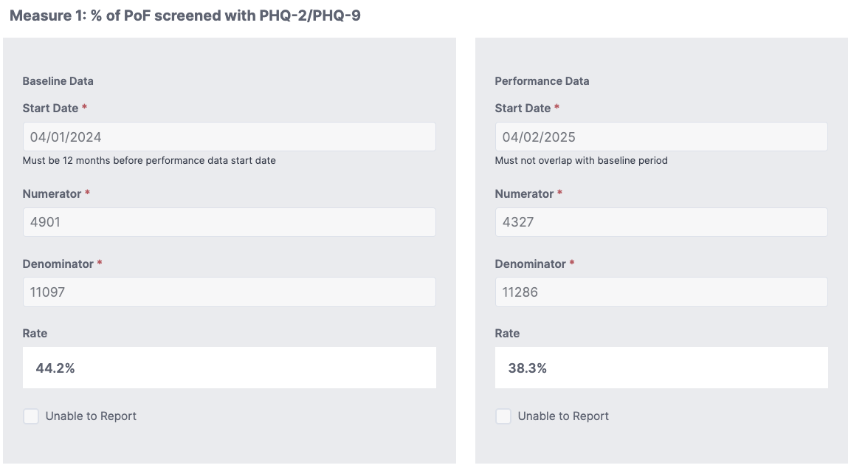

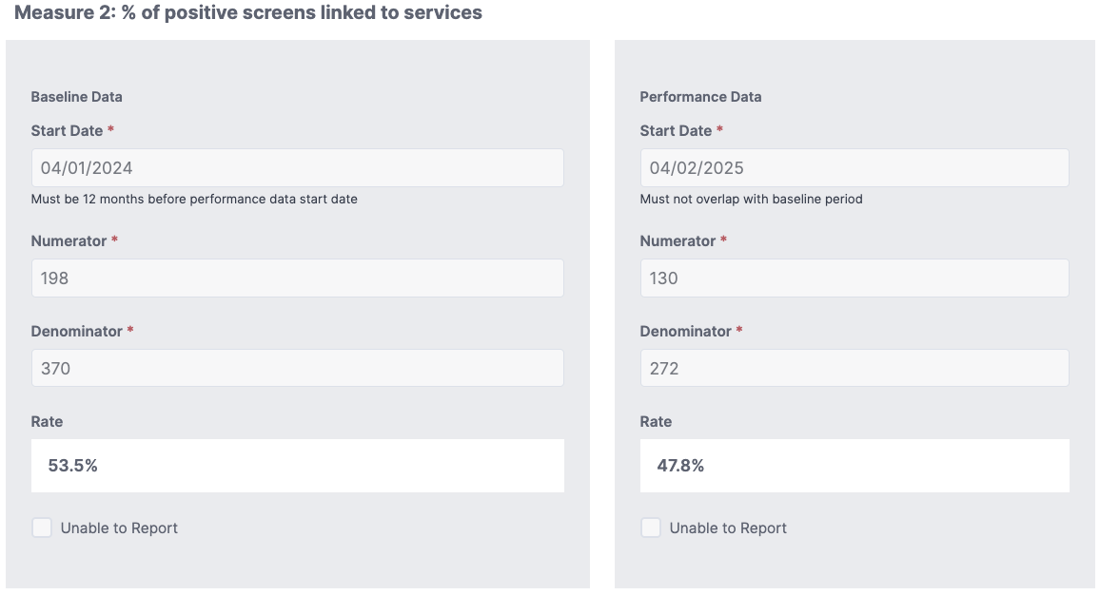
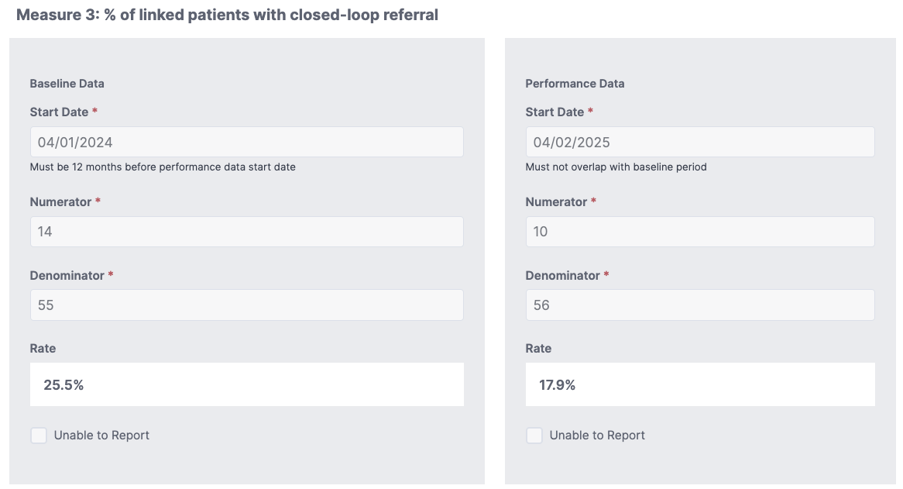

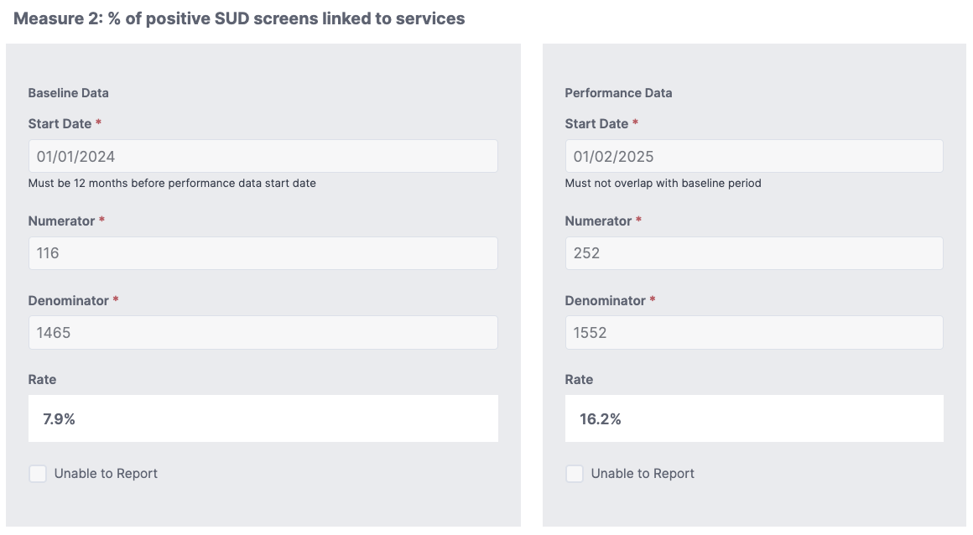
- SUD Screening & Linkage Baseline & Performance Data
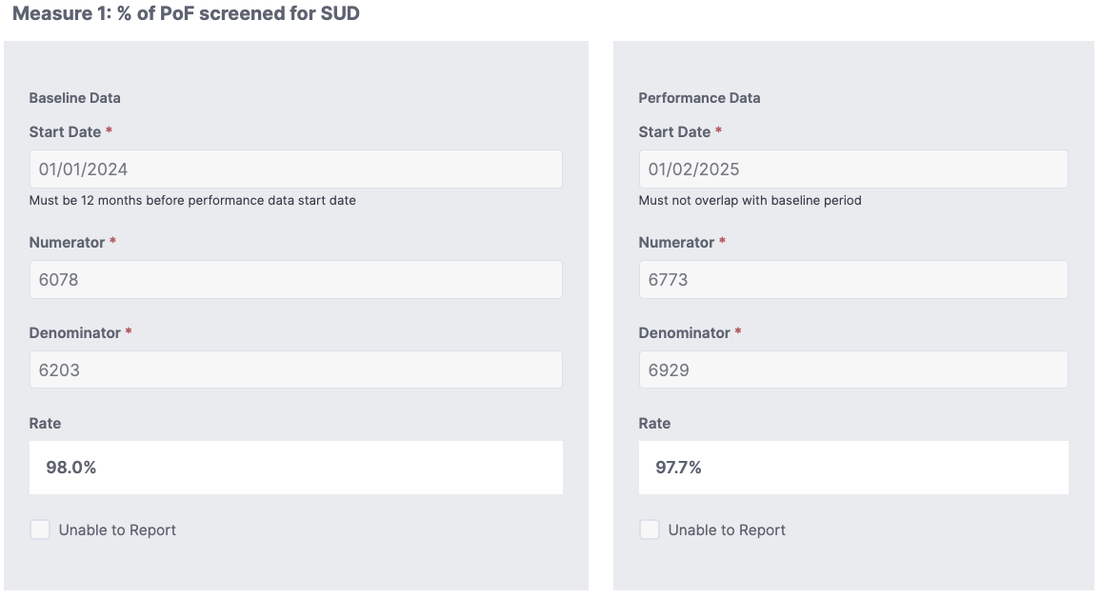
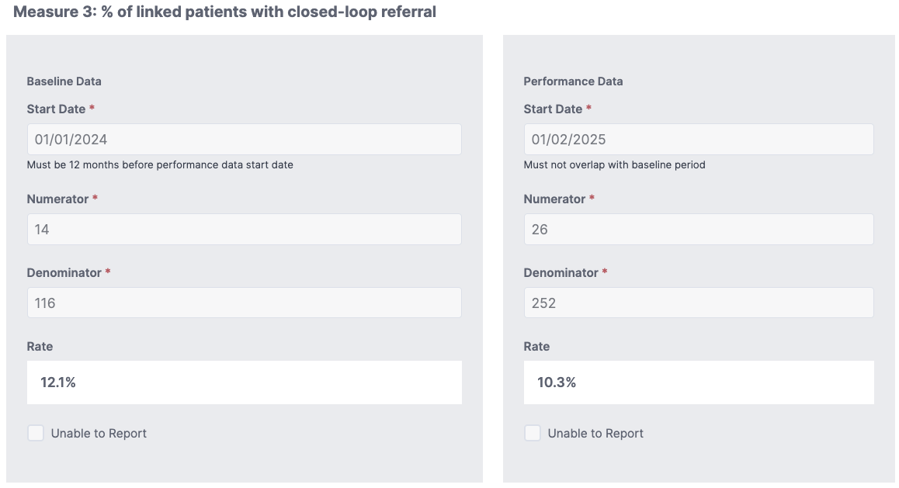

Part 2: Workflow Documentation
Complete the tables below to describe your workflows for depression and SUD screening, triage, and referral.

A. Depression Screening (PHQ-2/PHQ-9)

Workflow Component | Response
Who Screens | ✔ MA ✔ PCP ✔ BH Staff ✔ Other: Pop Health Coordinators
Screening Frequency | ☐ Every visit ✔ Annually ☐ At well visits ✔ Other: PRN
Administration Method | ✔ EHR form ✔ Patient portal ☐ Paper-based ✔ Verbal ☐ Tablet ☐ Other:
Triage/Intervention Protocols** | Screening Workflow Who screens & how often:  Medical Assistants (MAs):  - Administer PHQ-2 during rooming for all assigned patients and annually for all patients o If PHQ-2 is positive, escalate to PHQ-9 during the same visit o Administer SUD screening (standardized screening questions/CRAFT) per protocol  Providers:  - Review and validate screening results o Perform additional assessment as indicated  Data storage:  - All screening results are documented as structured data in Epic  - Results are visible on the patient Storyboard  - Positive screenings trigger Our Practice Advisories (OPAs) for provider action  Tiered Triage and Response Protocol  Tier 1: Negative / Low Risk Criteria:  - PHQ-2 negative or PHQ-9 score 0–4  - Negative SUD screening Interventions:  - No immediate intervention required • Reinforce availability of behavioral health services • Rescreen annually or sooner if clinically indicated  Tier 2: Mild to Moderate Risk Criteria:  • PHQ-9 score 5–14 • Mild to moderate SUD risk Interventions:  - Provider review and brief intervention (e.g., counseling, education, motivational interviewing)  - Offer referral to: Internal behavioral health services  - Community-based counseling or SUD services  - Schedule follow-up visit (in-person or telehealth) within appropriate timeframe (required within 30 days of the visit)  - Document care plan and referral in Epic  Tier 3: Moderate to High-Risk Criteria:  • PHQ-9 score ≥15 • Concerning SUD screening results • Any positive response to PHQ-9 Item 9 (suicidal ideation > 0)  - Escalation Steps: Immediate provider notification  - Provider conducts further clinical assessment  - Warm handoff to on-site behavioral health (if available)  - Initiate referral to higher level of care as appropriate  3. Suicide Risk Assessment & Response (PHQ-9 Item 9 > 0)  If a patient endorses suicidal ideation:  - Immediate Actions: • Patient is not left alone  - Provider performs real-time suicide risk assessment using:  - o Columbia-Suicide Severity Rating Scale (C-SSRS) or  - Structured clinical interview  - Assess severity, intent, plan, and means Risk-Based Response:  - Low Risk (passive ideation, no plan):  - Develop safety plan  - Provide crisis resources (e.g., 988 Suicide & Crisis Lifeline) o Arrange close follow-up (within 24–72 hours or sooner)  - Behavioral health referral  - Moderate Risk:  - Same as above + urgent behavioral health referral  - Consider same-day behavioral health consult (if available)  - • High Risk (active plan/intent):  - Activate emergency response: Call 911 or arrange transfer to nearest emergency department  - Ensure continuous supervision until handoff is complete
Data Storage | ✔ Structured EHR fields ☐ Manual tracking ✔ Population Health Platform ☐ Other:
Referral Process | Referral Pathways Patients are linked to appropriate behavioral health services based on risk level:  Internal Behavioral Health Services  Enhanced Care Management (ECM) or county referral for high-risk, complex patients  Community-based mental health and SUD providers  988 Suicide & Crisis Lifeline for immediate support All referrals are entered in Epic and tracked through our closed-loop referral process to ensure completion.  Documentation Standards  Screening results documented in structured fields in Epic  Provider assessment, risk stratification, and interventions documented in visit note  Suicide risk assessments (e.g., C-SSRS) documented when applicable  Referrals and follow-up plans documented and linked to orders  All outreach and follow-up attempts recorded  Follow-Up Procedures & Closed-Loop Tracking  Referrals tracked using Epic Close the Loop reports  Follow-up timelines based on risk level: o High risk: same day / immediate o Moderate risk: within days to 1 week o Mild risk: within 2–4 weeks  Referral Coordinators outreach to confirm connection to services  Multiple outreach attempts (calls, MyChart, letters) for non-responsive patients  Referral is not considered complete until confirmation of service connection is documented  Demonstration of Process Effectiveness  Reports available in Epic to track:  Screening completion rates (PHQ-2, PHQ-9, SUD) o Positive screening rates  Referral placement and completion rates  Ongoing monitoring through Population Health dashboards and workflow audits  Staff feedback indicates workflows are well-integrated and support timely identification and intervention
Training Plan for Staff | Who is trained:  - Medical Assistants  - Providers (Physicians, NPs, PA)  - Population Health Team (including referral coordinators/CHWs)  - Front Desk (awareness level)  - Clinic Managers and Supervisors  Training Approach and Format:  Our organization utilizes a multi-modal training approach to ensure consistent implementation of depression (PHQ-2/PHQ-9) and SUD screening, triage, and referral workflows.  1. Live Training Sessions  - Initial training provided through live, Epic certified trainer led sessions (in-person)  - Includes review of screening workflows, triage protocols, suicide risk response, and referral processes  - Incorporates real-life scenarios and role-based expectations  - Allows for interactive Q&A and clarification  2. Recorded Training Modules  - Recorded sessions are created for role-specific training refresher courses  - Accessible on-demand for ongoing reference and new staff onboarding  - Ensures consistency across all clinic sites  3. Epic Tip Sheets and Written Protocols  - Standardized Epic Tipsheets outlining:  - PHQ-2/PHQ-9 and SUD screening steps  - Triage levels and escalation pathways  - Suicide risk assessment workflow  - Referral and documentation requirements  - Available electronically and within clinic work areas for quick reference  4. Hands-On Workflow Training (Epic)  Training includes demonstration of documentation workflows in Epic (screening tools, OPAs, referrals, Close the Loop tracking)  Staff are guided through real-time examples to ensure comfort with system workflows  Training Leadership:  - Led by internal subject matter experts, including:  - Population Health leadership  - Epic Certified Trainer (for workflow and documentation training)  - Clinical leadership (e.g., Medical Director) for clinical protocols and risk assessment  Clinic managers support reinforcement at the site level  Training Frequency:  - Initial rollout: Provided to all current staff at time of implementation  - New hire onboarding: Incorporated into standard onboarding for all relevant roles  - Ongoing training:  - Annual refresher training for all staff  - Quarterly or as-needed updates based on workflow changes or performance data  - Targeted retraining:  - Conducted based on audit findings (e.g., missed screenings, documentation gaps, or escalation errors)  - Reinforced through staff meetings, rounding, and one-on-one coaching  Monitoring and Reinforcement:  - Workflow adherence monitored through Epic dashboard reporting (screening rates, referral completion, OPA compliance)  - Leadership and Population Health teams conduct periodic audits and rounding  - Real-time feedback and coaching provided to staff to ensure compliance and continuous improvement

**Protocols Must Include:
- Escalation steps for moderate to high risk (e.g., notify provider, on-site behavioral health consult, emergency services)
- Referral pathways (e.g., internal BH, mobile crisis unit, psychiatric emergency)
- A clear workflow if a patient endorses suicidal ideation (PHQ-9 item 9 score > 0) and subsequent real-time risk assessment (e.g., Columbia-Suicide Severity Rating Scale (C-SSRS) or clinical interview or 988 handoff)
- Documentation standards and follow-up procedures

B. SUD Screening
Workflow Component | Response
Who Screens | ✔ MA ✔ PCP ✔ BH Staff ✔ Other: Pop Health Coordinators
Screening Tool Used (Adult)** | ✔ AUDIT-C/DAST-10 ☐ ASSIST ✔ TAPS ☐ 4Ps** ☐ NIDA Quick Screen ☐ Other: __________
Screening Tool Used (Child/Adolescent)** | ✔ CRAAFT ☐ Other: __________
Screening Frequency | ☐ Every visit ✔ Annually ☐ At intake ☐ Other: PRN
Administration Method | ✔ EHR form ✔ Patient portal ☐ Paper-based ✔ Verbal ☐ Tablet ☐ Other: ________
Triage/Intervention Protocols** | Our organization utilizes a standardized, tiered response protocol for SUD screening using validated tools: AUDIT-C (alcohol use), DAST-10 (drug use) and CRAFFT (adolescents). Clinical responses are initiated for any non-zero score, with escalation based on tool-specific thresholds and clinical risk. All interventions incorporate motivational interviewing (MI) and assessment of the patient’s readiness for change.  Tier 1: Low Risk / Early Use (Non-Zero, Below Threshold)  Criteria:  - AUDIT-C: Score 1–2 (women) / 1–3 (men)  - DAST-10: Score 1–2  - CRAFFT: Score = 1  Interventions:  - Conduct brief intervention using motivational interviewing (MI)  - Assess readiness for change (stages of change model)  - Provide education on health risks and safe use guidelines  - Offer harm reduction strategies  - Provide optional resources for support  Response:  - No immediate referral required unless requested  - Document screening, MI discussion and readiness level in Epic  - Reassess at future visits  Tier 2: Moderate Risk (Meets Threshold for Intervention/Referral)  Criteria:  - AUDIT-C: ≥3 (women) / ≥4 (men)  - DAST-10: Score 3–5  - CRAFFT: Score ≥2  Interventions:  - Conduct structured brief intervention using MI  - Assess readiness for change and collaboratively set goals  - Provide counseling and education on reducing or stopping use  - Offer referral to:  - Behavioral health services  - Substance use counseling programs  - Community-based SUD services  Response:  - Place referral in Epic and initiate closed-loop referral tracking  - Schedule follow-up (typically within 1–4 weeks)  - Document intervention, readiness level and referral plan  Tier 3: High Risk / Likely Substance Use Disorder  Criteria:  - AUDIT-C: Significantly elevated scores with clinical concern  - DAST-10: Score ≥6  - CRAFFT: Score ≥2 with high-risk behaviors or functional impairment  Interventions:  - Immediate provider involvement  - Conduct comprehensive assessment including:  - Substance use history  - Co-occurring mental health conditions  - Readiness for change  - Utilize motivational interviewing to support engagement  - Initiate referral to higher level of care:  - Outpatient or inpatient SUD treatment programs  - Behavioral health services  - Medication-Assisted Treatment (MAT) programs  Response:  - Warm handoff whenever possible  - Initiate closed-loop referral tracking  - Arrange close follow-up (within days to 1 week)  Tier 4: Emergent / High-Risk Safety Concerns  Criteria:  - Signs of overdose risk, severe withdrawal or acute intoxication  - Co-occurring behavioral health crisis (e.g., suicidal ideation)  Interventions & Escalation:  - Immediate provider assessment  - Do not leave patient unattended if safety concerns are present  - Activate emergency response:  - Call 911 or transfer to emergency department  Provide overdose prevention education and resources (Naloxone is kept in stock at our clinics and provided to patients at no cost)  Documentation Standards  - Screening results documented in structured Epic fields  - Care plan documented in provider note  - Referrals entered and tracked through closed-loop referral process  - Follow-up attempts and outcomes documented  Follow-Up and Monitoring  - Low risk: reassess at next visit  - Moderate risk: follow-up within 1–4 weeks  - High risk: close follow-up within days to 1 week  Population Health and referrals teams supports outreach and engagement, including multiple attempts for non-responsive patients  This protocol ensures that all patients with any level of substance use receive an appropriate, evidence-based response, with increasing intensity of intervention based on validated screening thresholds and clinical judgment, while emphasizing motivational interviewing, patient engagement and closed-loop care coordination.
Data Storage | ✔ Structured EHR fields ☐ Manual tracking ☐ Population Health Platform ☐Other:
Referral Process | Our organization utilizes a structured referral process for SUD services that includes clearly defined local referral pathways, standardized initiation within Epic and a closed-loop tracking system to ensure patients successfully connect to services.  1. Available Referrals for SUD in Our Service Area  Patients identified with SUD needs are referred to a range of services across Monterey County based on severity, age, and readiness for treatment:  - Internal services:  - Behavioral health: psychiatric nurse practitioner  - Medication-Assisted Treatment (MAT) programs  - CHW  - County Behavioral Health  - Community-Based SUD Treatment Providers:  - Community Human Services- outpatient counseling, residential treatment, MAT programs  - Sun Street Centers- prevention, treatment and recovery services regardless of income  - Door to Hope- outpatient, residential and family-centered behavioral health services  - Valley Health Associates- youth and adult outpatient SUD treatment, including opioid treatment programs  - Hospital-Based / Higher Level of Care:  - Community Hospital of the Monterey Peninsula Alcohol and Drug Recovery Program- structured recovery and treatment services  - Additional Treatment Options:  - Intensive outpatient programs (IOP), residential treatment, detox, and dual-diagnosis programs available throughout the region  - CalAIM Programs:  - Enhanced Care Management  - Community Supports  Referrals are individualized based on clinical risk, patient preference, insurance coverage, and access barriers.  2. Referral Initiation  - Referrals are initiated by providers within Epic at the time of the visit  - Screening results (AUDIT-C, DAST-10, CRAFFT), risk level and clinical notes are included to guide appropriate placement  - When possible, warm handoffs are conducted (e.g., assisting patient in calling or connecting with internal staff before leaving)  - Patients receive verbal counseling, written resources, and/or MyChart follow-up instructions  3. Referral Tracking (Closed-Loop Process)  We utilize Epic’s “Close the Loop” referral tracking workflow:  Report used: Close the Loop – Follow Up – Outpatient Referrals  Tracking workflow:  - If documentation is received (consult notes, program intake, treatment updates):  - Indexed into Epic (via OnBase or electronic interface)  - Referral marked complete (“loop closed”)  - If no documentation is received:  - Staff contacts the referred-to organization  - Outreach to patient to confirm engagement  - “No documentation received” note entered  - Referral remains active for continued follow-up  - Referrals are also reviewed during Pre-Visit Planning (PVP) to address gaps prior to future visits.  4. Determining if Services Were Received  We confirm successful linkage through:  - Receipt of documentation from the SUD provider/program  - Electronic interface results (CHOMP Hospital)  - Direct communication with the referred organization  - Patient-reported confirmation during outreach or subsequent visits  A referral is only considered complete once service connection is verified and documented, ensuring a true closed-loop referral system.  5. Follow-Up and Engagement for Hard-to-Reach Patients  - To support engagement, particularly for patients with SUD:  - Minimum of three outreach attempts at different days/times  - Multi-modal outreach:  - Phone  - MyChart  - Letters  - Warm handoffs to Population Health team or CHWs for navigation support  - Assistance addressing barriers (transportation, language, scheduling, stigma)  - Re-engagement during future visits if initial outreach is unsuccessful  This referral process ensures that patients with SUD are not only identified and referred, but actively supported through connection to appropriate services with robust tracking and follow-up to ensure meaningful engagement and improved outcomes.
Training Plan for Staff | Who is trained:  - MAs  - Providers (Physicians, NPs, PAs)  - Population Health Team (including referral coordinators/CHWs)  - Clinic Managers and Supervisors  - Front Desk staff  Training Approach and Format:  Our organization utilizes a multi-modal, role-based training approach to ensure consistent implementation of depression (PHQ-2/PHQ-9) and SUD (AUDIT-C, DAST-10, CRAFFT) screening, triage, and referral workflows.  - Live Training Sessions: Initial training is delivered through live, Epic certified trainer led sessions covering screening workflows, triage protocols, suicide risk response and referral processes. Sessions include case-based scenarios and role-specific expectations.  - Recorded Training Modules: Trainings are recorded and distributed as short, role-specific video modules for ongoing reference and onboarding.  - Epic Tipsheets and Written Protocols: Standardized job aids outline screening steps, triage levels, escalation pathways (including suicide risk/C-SSRS), SUD intervention protocols and documentation requirements in Epic.  - Hands-On Epic Training: Staff receive workflow-based training within Epic, including use of screening tools, Our Practice Advisories (OPAs), referral placement and Close the Loop tracking.  Training Leadership:  - Population Health leadership (workflow and program oversight)  - Epic Certified Trainer (system workflows and documentation)  - Clinical leadership/Medical Director (clinical protocols, risk assessment, MI)  - Clinic Managers (site-level reinforcement and coaching)  Training Frequency:  - Initial rollout: Provided to all staff at implementation  - New hire onboarding: Included as part of standard onboarding  - Ongoing training: Annual refresher training for all staff  - Targeted retraining: Conducted quarterly or as needed based on performance data, audits or workflow updates  Monitoring and Reinforcement:  - Compliance monitored through Epic dashboard reports (screening rates, OPA usage, referral completion)  - Workflow audits and rounding conducted by leadership and Population Health team  - Real-time feedback and coaching provided to ensure adherence and continuous improvement

Protocols must include:
- Protocol clearly defines risk assessment workflow, specific interventions, crisis escalation steps, and referral protocol. This should include the use of motivational interviewing (MI), assessment of the patient’s readiness for change, and appropriate risk assessment and response.
- Clearly defined workflow for mild, moderate, and severe acuity levels (e.g., SBIRT, Stages of Change). Indicates use of MAT if applicable to the practice capabilities.
- Outlines crisis response expectations
- Cultural considerations are outlined in the protocol

3. Evidence of Implementation
To meet this milestone, your practice must implement at least two new actions (since the start of EPT) focused on depression screening and follow-up using the PHQ-2/PHQ-9 and substance use disorder (SUD) screening and linkage for your selected PoF. Practices should report at least one action for depression and one action for SUD screening and linkage to care. For each action, include the date it was launched (i.e., when it began being used with patients), the number of patients impacted, how success was measured, and any observed outcomes. Small-scale pilots or PDSA cycles are acceptable as evidence.
- Note: Results may be qualitative (e.g., staff feedback on ease of workflow, patient engagement) or quantitative (e.g., screening and referral rates, reduced missed appointments). Qualitative reporting should provide clear, narrative descriptions of observed outcomes—such as “Medical assistants reported that the new screening workflow is easy to follow and integrates smoothly into patient intake,” or “Providers noted increased patient openness to discussing behavioral health concerns”—that illustrate the real-world impact of implementation with specific, concrete examples.

 | Action 1
Implemented Action | In August 2025 our organization implemented a standardized follow-up workflow for patients with positive depression screenings (PHQ-9) to ensure timely reassessment and linkage to care. Prior to this implementation, while depression screening was performed, we did not have a consistent or systematic process to ensure follow-up after a positive screen.  This action introduced a structured Epic work queue that automatically captures patients with positive PHQ-9 results. These patients are routed to a dedicated Population Health workflow, where assigned staff are responsible for outreach and care coordination.  Key components of the implementation include:  - Automated identification: Patients with positive PHQ-9 screenings are placed into an Epic work queue for tracking  - Dedicated outreach: Designated staff conduct outreach to schedule follow-up care  - Timely follow-up: Patients are contacted and offered follow-up visits within 30 days of the positive screening  - Telemedicine access: Telehealth visits are offered to reduce barriers to care and improve access, particularly for patients with transportation or scheduling challenges  - Care coordination: Follow-up visits include reassessment, provider evaluation and referral to behavioral health services as appropriate  - Closed-loop tracking: Patients remain in the work queue until follow-up is completed or multiple outreach attempts have been documented  This workflow was implemented across all clinic sites and supported by Population Health leadership, Epic build enhancements and clinic staff training. The scope includes all patients with positive depression screenings within our population of focus.  To address the decrease in our screening rates, one factor that impacted our data was the reporting guidelines for depression screening changed mid-year in 2025. Prior to this change, patients with an existing positive depression diagnosis were excluded from the depression screening measure denominator. After the guideline update, these patients were included and required ongoing screening. As a result, the data had to be rerun using the updated methodology, which significantly increased the denominator and impacted comparisons between baseline and performance data.  Although the current reporting baseline data reflects a depression screening rate of 44.2%, our screening performance remained relatively stable when compared to pre-guideline change data, where our rate was 38.29%. This suggests that operational screening performance did not significantly decline but rather that the updated reporting methodology created a larger eligible screening population.  Another major workflow change involved implementation of a dedicated Epic work queue for patients with positive depression screenings. Prior to this change, follow-up actions were commonly processed through the referral workflow, which allowed them to be counted within our “linked to services” and “close the loop” metrics. Under the new workflow, patients requiring internal follow-up are routed into a depression follow-up work queue managed by Population Health staff rather than through a formal referral order.  As a result:  - Internal follow-up visits are no longer consistently captured as an official “linked to services” referral event  - Internal follow-up workflows are not currently tracked within the existing “Close the Loop” referral reporting structure  - This likely contributed to apparent declines in:  - Positive depression screening linked to services Close the loop referral rates  Despite these reporting limitations, operational follow-up efforts significantly improved during this cycle. Specifically, confirmed follow-up within 30 days after a positive depression screening increased from 19.60% to 47.06%, demonstrating substantial improvement in patient outreach, reassessment, and engagement.
Date of Implementation | 8/1/2025
Results Observed | Since implementing the standardized follow-up workflow for patients with positive depression screenings, our organization has observed meaningful improvements in care coordination, patient engagement and follow-through.  Process Improvements:  - Established a reliable, standardized follow-up system, ensuring patients with positive PHQ-9 screenings are no longer missed after initial identification  - Improved visibility and accountability through the Epic work queue, allowing staff to actively manage and track follow-up needs  - Increased efficiency by assigning dedicated staff to oversee outreach and scheduling  Patient Access and Engagement:  - Increased completion of follow-up visits within the targeted 30-day timeframe, supported by proactive outreach  - Telemedicine availability has reduced barriers such as transportation and scheduling conflicts, improving patient participation  - Staff report that patients are more willing to engage in follow-up care when contacted directly and offered flexible visit options  Care Coordination and Outcomes:  - Improved timeliness of reassessment and intervention for patients with depression  - Increased identification of patients needing additional behavioral health support, resulting in more appropriate referrals  - Strengthened connection to behavioral health services through more consistent follow-up and referral placement  - Staff Feedback (Qualitative):  - Population Health staff report the workqueue is easy to manage and provides clear direction on outreach priorities  Overall, this action has significantly improved our ability to close the gap between screening and treatment, ensuring that patients with identified depression receive timely follow-up, reassessment and connection to appropriate care.

 | Action 2
Implemented Action | In June 2025, our organization implemented a hard stop Our Practice Advisory (OPA) within Epic to strengthen follow-up and intervention for patients with positive tobacco use screenings, as part of our broader Substance Use Disorder (SUD) screening and linkage efforts.  Prior to this implementation, tobacco screening completion rates were high; however, follow-up actions, such as cessation counseling or referrals, were not consistently performed or documented. This resulted in missed opportunities to intervene on a key SUD-related risk factor.  To address this gap, we implemented a hard stop OPA that triggers for providers when a patient screens positive for tobacco use. The OPA requires the provider to take and document one of the following actions before closing the encounter:  - Provide tobacco cessation counseling (brief intervention using motivational interviewing techniques)  - Place a referral for cessation support services, including behavioral health, quit programs or community-based resources  Key components of the implementation include:  - Real-time provider prompt: The OPA ensures providers are alerted during the visit and cannot bypass the required action  - Standardized intervention: Providers are guided to deliver evidence-based brief interventions and assess readiness for change  - Referral integration: Direct referral pathways are embedded within the workflow to streamline connection to cessation resources  - Documentation requirement: Providers must document the intervention or referral, improving data capture and compliance with quality metrics  This change was implemented across all clinic sites and supported by Epic build enhancements, Population Health leadership and provider training. The scope includes all patients who screen positive for tobacco use, ensuring consistent intervention and strengthening linkage to treatment and support services.
Date of Implementation | 6/13/2025
Results Observed | Since implementing the hard stop OPA for tobacco screening follow-up in June 2025, our organization has observed improvements in provider intervention, documentation and overall management of patients who screen positive for tobacco use.  Process Improvements:  - Established a reliable, standardized workflow ensuring that every positive tobacco screening results in a documented intervention or referral  - Eliminated variability in provider response by requiring action prior to closing the encounter  - Improved documentation accuracy and completeness, supporting quality reporting and compliance with CBI/QIP metrics  Provider Engagement and Clinical Practice:  - Improved provider awareness and accountability, as the OPA serves as a real-time reminder to address tobacco use during the visit  - Providers report the workflow is clear and actionable  Patient Care and Outcomes:  - Increased number of patients receiving cessation counseling and referrals to support services  - Improved identification of patients ready to quit and connection to appropriate resources  Staff Feedback (Qualitative):  - Leadership has observed improved performance trends in tobacco-related quality metrics  Overall, this action has strengthened our ability to translate screening into meaningful clinical intervention, ensuring that patients who screen positive for tobacco use receive timely counseling and linkage to cessation resources.

Appendix: Screening Tool Scoring Guides

PHQ-9 (Patient Health Questionnaire-9)
The PHQ-9 consists of 9 items, each scored from 0 (Not at all) to 3 (Nearly every day). Total score range: 0–27.
Scoring Interpretation:
- 0-4: Minimal or no depression
- 5-9: Mild symptoms — consider monitoring or brief intervention
- 10-14: Moderate — positive screen; recommend further evaluation and referral
- 15-19: Moderately severe — active treatment likely needed
- 20-27: Severe — active treatment and possible specialty referral recommended

Of course, any non-zero screening requires a clinical conversation and clinical discretion.

AUDIT-C (Alcohol Use Disorders Identification Test - Consumption)
The AUDIT-C includes 3 questions on alcohol consumption, each scored from 0-4. Total score range: 0-12.
Scoring Interpretation:
- Men: A score of 4 or more is considered a positive screen
- Women: A score of 3 or more is considered a positive screen
- Any score above 0 may warrant brief counseling depending on context

CRAFFT (Adolescent Substance Use Screening Tool)
The CRAFFT is a brief screening tool for adolescents (generally ages 12–21) used to identify risky alcohol and drug use. It has two parts: Part A (use questions) and Part B (six risk items: C-R-A-F-F-T).
Scoring Method
- Part A (Use History)
  - Ask whether the adolescent has used alcohol (more than a few sips), marijuana, or other substances in the past 12 months.
  - If the adolescent endorses any substance use, administer all six Part B questions.
  - If no substance use is endorsed, administer only the "Car" question from Part B.
- Part B (Risk Behaviors)
  - Each “yes” response counts as 1 point.
  - Total score range: 0–6.
Interpretation
- 0 points: Low risk. Reinforce healthy behaviors and provide preventive counseling.
- 1–2 points: Moderate risk. Conduct further assessment and provide a brief intervention using motivational interviewing.
- 3 or more points: High risk. Indicates likely substance use disorder; consider diagnostic evaluation, referral to treatment, and involve caregivers when appropriate.
Additional Notes
- The "Car" question is always asked, even if no substance use is reported.

DAST-10 (Drug Abuse Screening Test)
The DAST-10 includes 10 yes/no questions about drug use (not including alcohol or tobacco). Each 'yes' response scores 1 point. Total score range: 0-10.
Scoring Interpretation:
- 0: No problems reported
- 1–2: Low level — monitor and reassess
- 3–5: Moderate level — consider brief intervention
- 6–8: Substantial level — referral to treatment recommended
- 9–10: Severe level — intensive assessment and treatment indicated

SBIRT (Screening, Brief Intervention, and Referral to Treatment)
SBIRT is not a specific screener but a comprehensive, public health approach to identifying and intervening with individuals at risk for substance use disorders. It incorporates validated screening tools (e.g., AUDIT, DAST) and uses the risk level to determine appropriate follow-up.
General Interpretation:
- Low Risk: Provide positive reinforcement
- Moderate Risk: Conduct a brief intervention
- High Risk: Refer to specialty treatment and provide follow-up
Additional trainings and reference materials for SBIRT are provided below:
Screening, Brief Intervention and Referral to Treatment (SBIRT) in Behavioral Healthcare
Implementing SBIRT (Screening, Brief Intervention and Referral to Treatment) in primary care: lessons learned from a multi-practice evaluation portfolio
SBIRT: Screening, Brief Intervention, and Referral to Treatment

TAPS (Tobacco, Alcohol, Prescription Medication, and Other Substance Use)
The TAPS tool includes a 2-part screen:
- TAPS-1: A brief screening (yes/no) on past 12-month use
- TAPS-2: A follow-up that evaluates frequency of use for substances reported in TAPS-1
Scoring Interpretation (TAPS-2):
- Score of 1: Occasional use — brief intervention may be sufficient
- Score of 2+: Indicates more frequent use — further assessment or referral recommended
- A score of 2 or more for any substance is generally considered a positive screen

ASSIST-LITE (Alcohol, Smoking and Substance Involvement Screening Test – Lite Version)
The ASSIST-LITE is a shorter version of the original WHO ASSIST tool, developed to quickly identify substance use risk across various categories (alcohol, cannabis, cocaine, etc.). It is suitable for primary care and time-limited settings.
Scoring Interpretation (by substance):
- 0-3: Low risk — no intervention needed
- 4-26: Moderate risk — brief intervention recommended
- 27+: High risk — referral for specialty treatment
(Note: Exact cut points may vary by setting; use clinical judgment.)

4Ps Plus:
The 4Ps Plus® is a brief, validated screening tool designed to identify substance use risk during pregnancy in a safe, nonjudgmental way. It helps providers open a supportive conversation early in prenatal care. (Distinct from actual substance-use risk level)
A “yes” to any question signals the need for further discussion, not judgment. The goal is to identify risk early, provide brief intervention or education, and connect patients with support when needed. A “Yes” response triggers action to complete one of the validated measures listed above.
C-SSRS (Columbia–Suicide Severity Rating Scale)
The C-SSRS is a brief, evidence-based tool used to identify the presence and severity of suicidal ideation and behavior. It is suitable for primary care, behavioral health, and any setting where suicide risk needs to be assessed quickly and clearly.
Scoring Interpretation:
- Ideation Levels (1–5):
  - 1–2: Lower-level suicidal ideation (wish to be dead or non-specific thoughts) — monitor, assess contributing factors, provide psychoeducation.
  - 3–5: Clinically significant active suicidal ideation (method, intent, or plan) — requires a more detailed safety assessment and intervention.
- Behavior Items:
  - Any endorsed suicidal behavior (e.g., preparatory actions, aborted or actual attempts) indicates elevated risk and warrants immediate, more intensive clinical follow-up.
(Note: The C-SSRS is not scored by adding points; the highest level of ideation or behavior endorsed determines clinical concern. Use clinical judgment and consider risk/protective factors.)
Link to Training: FREE Training for Individuals and Systems - The Columbia Lighthouse Project

