Patient Health Questionnaire Workflow

Purpose: The purpose of this workflow is to identify individuals who may be experiencing depressive symptoms over the past two weeks using a validated screening tool to support early identification and timely clinical follow-up.

PHQ-2
PHQ-2 to be completed at every visit for patients ages 12 and older
**Note: If the patient scores a 3 or higher on the PHQ-2, the PHQ-9 will automatically launch. Follow PHQ-9 workflow below.**

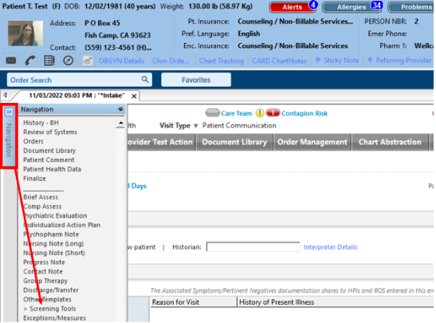
- To open Screening tools, click on Navigation Bar ( can be opened from INTAKE or SOAP)
- Select Screening tools
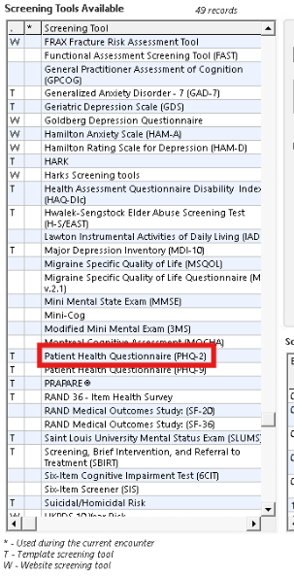
- Click Patient health questionnaire (PHQ-2) link.
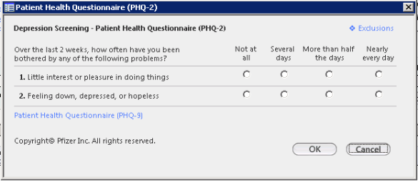
- Complete all questions with patient.
- Click OK.
- Once screening has been completed, the “Screening Tool List” will display.
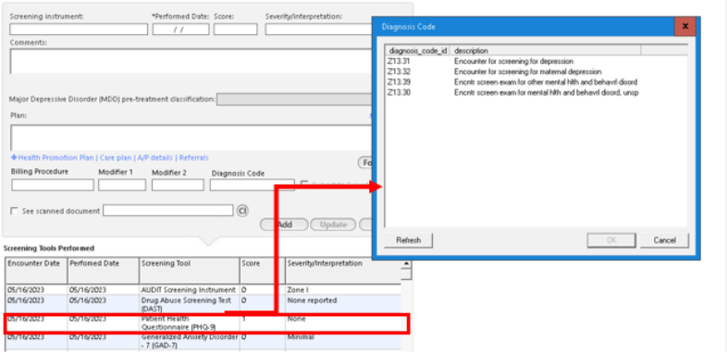
- Ensure to attach diagnosis:
- Highlight Screening
- Click on Diagnosis Code field this will display Diagnosis code template.
- Select Diagnosis code Z30.31
- Click on the Update button when completed.

PHQ-9
Note the PHQ-9 must be completed annually at all well-child and well-adult visits, regardless of PHQ-2 screening results

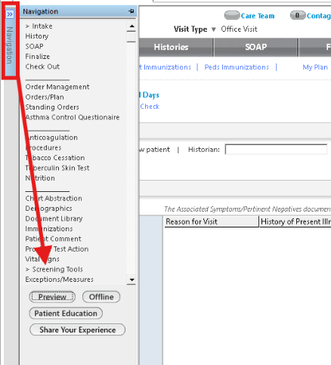
- To open Screening tools Click on Navigation Bar
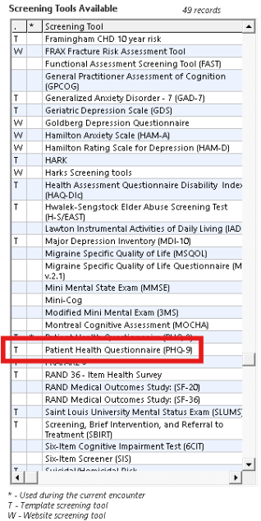

- Once Screening Tools Template open select Patient Health Questionnnaire – 9 (PHQ)
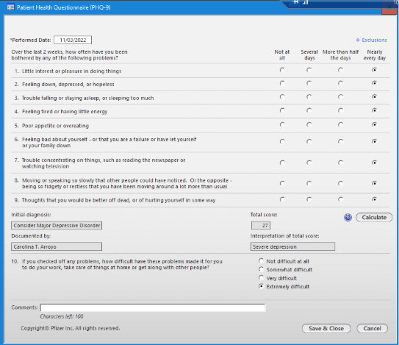
- Complete all questions with patient
- Save and Close when completed
- Once screening has been saved and closed Screening Tool List will display
- Ensure to attach Diagnosis:
- Highlight screening
- Click on Diagnosis code field this will display Diagnosis Code template.
- Select Diagnosis code Z30.31
- Click on the update button when completed.
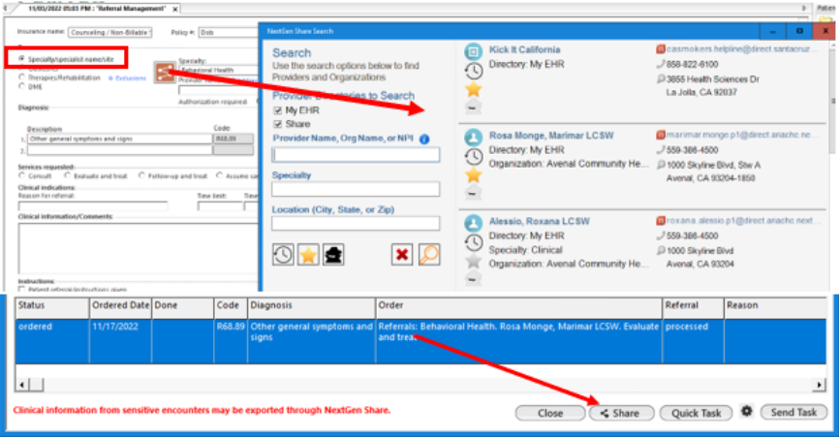
- For patients with a score of 10 or higher a depression follow-up plan must be documented on the date of the visit.
**Note: A follow-up plan could be additional evaluation by another provider, referral, treatment, pharmacological intervention. **
- Place referral for Behavioral health for in-house referrals usethe Nextgen share and select BH provider.
- Once referral is placed, highlight referral and Click the Share button
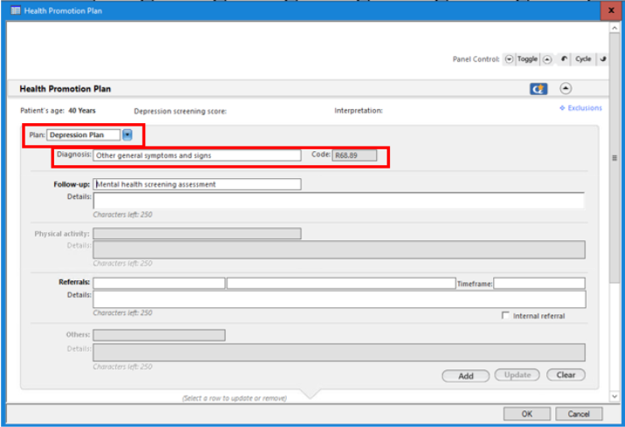

- If case Manager is completing screenings complete Depression Plan from Health Promtion plan
- Place referral for in-house referral use the Nextgen Share and select BH Provider
- For non-in-house referral place Specialty of Behavioral Health and task to referral department tgroup for corresponding site.

Follow up
Follow up must be conducted within 30 days of positive score of 10 or higher.

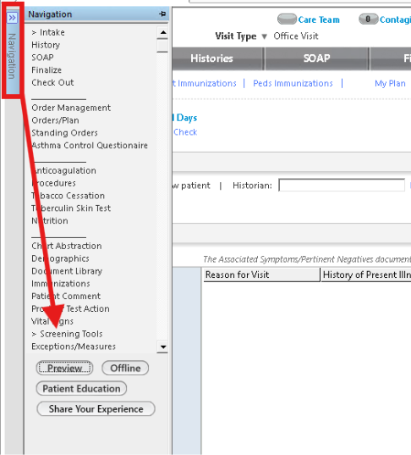
- Open Navigation Bar

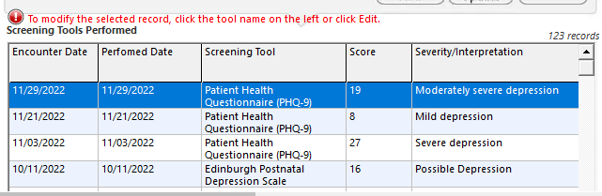
- Select Positive results screening

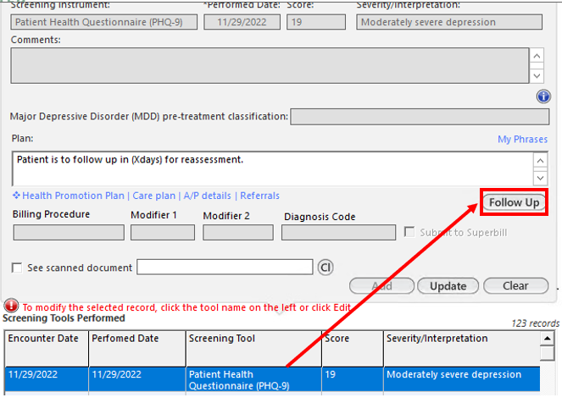
- Click on Follow up
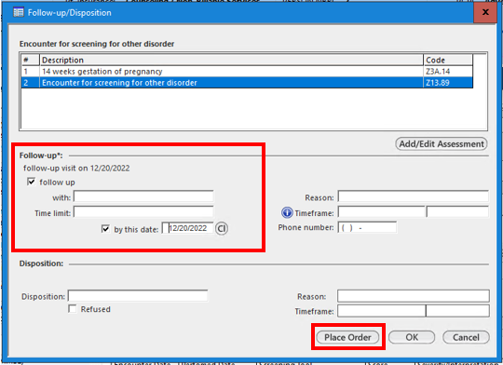
- Enter Date (if patient has been scheduled with counseling enter date of appointment) for patients who declined counseling make follow up within 30 days for screening
- Place order
- Click OK to close Follow-up template.

